**6. The Story of Thomas**

**Reading:** John 20: 24-29

Thomas was one of the twelve, but he was not with the other followers when Jesus came. They told him, “We saw the Lord.” Thomas said, “That’s hard to believe. I will have to see the nail holes in his hands, put my finger where the nails were, and put my hand into his side. Only then will I believe it.”

A week later the followers were in the house again, and Thomas was with them. The doors were locked, but Jesus came and stood among them. He said, “Peace be with you!” Then he said to Thomas, “Put your finger here. Look at my hands. Put your hand here in my side. Stop doubting and believe.”

Thomas said to Jesus, “My Lord and my God!”

Jesus said to him, “You believe because you see me. Great blessings belong to the people who believe without seeing me!”

**Thought about the reading**

All of Jesus’s friends had seen him alive after he had risen from the dead. All of them except Thomas. Maybe he was busy when Jesus appeared. He found it hard to believe that someone could really come back to life after they have died. He wanted to see for himself. When at last he saw Jesus, then he believed.

Jesus said that those who have not seen him, but still believe are blessed, or happy. He is talking about us! We have not yet seen him, but we still believe that he is alive. Like Thomas, we can say, ‘My Lord and my God.’

We can be sure that Jesus is alive in heaven. We know that one day, we will be with him, and we will see him at last.

**Prayer**

Lord Jesus, thank you for the story of Thomas, who found it hard to believe you were alive until he saw you for himself. We cannot see you now, but please help us to believe. Help us to look forward to a time when we will see you in heaven.

Amen

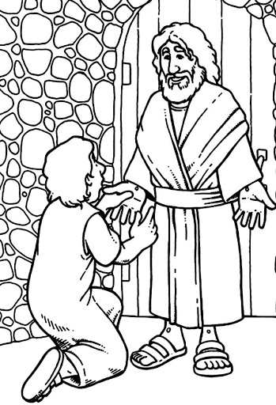

**Cambridge Causeway**

Summer 2021

Bible Study notes

**Eyewitnesses**

**6. The Story of Thomas**

By Chrissy Cole